

CSC1011H FINAL REPORT

Date: 18 May 2026
Course convener: Gary Stewart
Authors: Ayanda Majola and Luvolwethu Mdala

Contents
1. Introduction 2
1.1 Background to the Project 2
1.2 Project Requirements 2
1.3 Report Structure 3
2. Project Management 4
2.1 Development Approach 4
2.2 Development Team 4
2.3 Tools and Technologies 4
2.4 Challenges Encountered 5
2.5 Project Plan - High-Level Schedule 5
3. Design 6
3.1 Low-Fidelity Prototype 7
3.2 High-Fidelity Prototype 8
3.3 Final User Interface Design 9
4. Implementation 10
4.1 Class Architecture 10
4.2 Networking and Threading 11
4.3 Server Message Protocol 11
4.4 Connected Window 12
4.5 Game Over Popups 12
4.6 Help Screen 14
4.7 Colour Theme Feature 15
5. Testing 16
5.1 Correctness Testing 16
5.2 User Testing 17
5.2.1 Text-Based Client Feedback 18
5.2.2 GUI Prototype Feedback 18
5.2.3 Changes Made in Response 19
6. Enhancements & Future Work 20
6.1 Enhancements Implemented 20
6.1.1 Seven-Colour Background Theme Selector 20
6.1.2 Interactive Help Screen 20
6.1.3 Animated Result Popups 20
6.1.4 Colour-Coded Timestamped Message Log 21
6.2 Future Work 21
6.2.1 AI Solo-Player Mode 21
6.2.2 Persistent Score Tracking 21
6.2.3 Matchmaking Lobby 21
6.2.4 Sound Effects 22
6.2.5 Responsive Layout and Larger Board Options 22
7. Conclusion 23
Appendix A - Source Code: OXOGUIClient.py 24

Introduction
The purpose of this project was to design and develop a playable OXO (Tic-Tac-Toe) game client that communicates with a game server across a network. The project was commissioned by Ten Eleven Games, a game development company, and was completed as part of the CSC1011H (Database and Web Programming) module at the University of Cape Town.

OXO is a two-player strategy game played on a three-by-three grid. Each player takes turns placing their symbol X or O on an empty cell. The first player to place three symbols consecutively in a row, column, or diagonal wins the game. If all nine cells are filled without a winner, the game ends in a draw. In this networked version, two players connect to a shared OXO Game Server from separate machines over a local network.

1.1 Background to the Project
The project began with creating a text-based client that allows two players to connect to the server, make moves, receive updates, and play multiple rounds. After this, the project progressed to designing a graphical user interface (GUI) using PyQt5 in Python. The OXO Game Server was provided by the course lecturers; the student team was responsible for building the client only.

1.2 Project Requirements
The following functional and non-functional requirements were defined for the project:

Functional Requirements:
- The client must connect to the provided OXO Game Server using TCP sockets.
- Two players must be able to play against each other from separate machines.
- The client must handle all eight server message types: new game, your move, opponents move, valid move, invalid move, game over, play again, and exit game.
- The board must update correctly after every valid move by either player.
- Players must be able to request a new game or exit cleanly after each round.

Non-Functional Requirements:
- The interface must clearly indicate whose turn it is at all times.
- Error conditions must produce informative, colour-coded feedback.
- The system must not freeze or crash if the server disconnects unexpectedly.
- The codebase must be well-commented and maintainable.

1.3 Report Structure
The remainder of this report is organised as follows. Section 2 describes how the project was managed and provides the full project plan. Section 3 covers the design process, including the low- and high-fidelity prototypes and the final interface. Section 4 describes the implementation. Section 5 documents both correctness and user testing. Section 6 covers enhancements and future work. Section 7 presents the conclusion. The appendix contains the fully commented source code.

Project Management
The project was managed by following a structured work plan that divided the overall deliverable into five sequential phases. Rather than leaving all work until the final deadline, each phase was treated as an independent milestone with its own tasks, time estimates, and submission date. This incremental approach ensured that problems were identified and resolved early, and that feedback from earlier phases could inform later ones.

2.1 Development Approach
An incremental delivery model was adopted because each assignment introduced new technology sockets, PyQt5, threading that had to be mastered before the next phase could begin. Regular testing was performed after implementing each feature to ensure the program worked correctly and to identify errors early. Feedback from the tutor on the low-fidelity prototype was incorporated before developing the high-fidelity GUI, and user testing in Assignment 9 produced specific improvements implemented in Assignment 10.

2.2 Development Team
This project was developed by two students working in partnership, both equally responsible for quality and timely delivery. Tasks were shared as evenly as possible, with each developer taking the lead on alternating tasks. The developers are identified by their initials throughout the project plan: AM (Ayanda Majola) and LM (Luvolwethu Mdala).

2.3 Tools and Technologies
Tool / Technology | Purpose
Python 3.x | Primary programming language
PyQt5 | Graphical user interface framework
socket (stdlib) | TCP networking between client and server
threading (stdlib) | Background thread for non-blocking message receipt
pyqtSignal | Thread-safe GUI updates from the background thread
blank.gif / cross.gif / nought.gif | Cell icons for empty, X, and O board states
VS Code | Code editor and debugger
Git | Version control and backup
MS Word | Report writing and documentation

2.4 Challenges Encountered
The following key challenges were identified and resolved during development:

- Thread-safe GUI updates: PyQt5 prohibits direct widget modification from a background thread. This was resolved by using a pyqtSignal that emits server messages from the receive thread and processes them on the main thread via the connected handle_message() slot.
- Non-blocking socket receive: Calling socket.recv() in a loop without a timeout blocks indefinitely if no message arrives, potentially freezing the thread. This was resolved by setting a one-second socket timeout and catching socket.timeout to continue the loop.
- Occupied cell detection: Determining whether a board cell had already been used required comparing the QIcon cache key of the cell against the blank icon's cache key, a non-obvious PyQt5 idiom discovered through testing.
- Popup centring and resizing: The ResultPopup had to remain centred inside the main window even when the window was moved or resized. This required overriding both resizeEvent() and moveEvent() in OXOGUIClient.

2.5 Project Plan - High-Level Schedule
The following table summarises the five deliverables, their technology focus, and scheduled dates.

Del. | Deliverable | Technology | Focus | Start | End | Due
1 | Text-Based OXO Client | Python / Sockets | Networking + Logic | 13 April | 18 April | 20 April 2026
2 | GUI Prototype | PyQt5 | Visual layout | 20 April | 26 April | 27 April 2026
3 | Final System Alpha | PyQt5 + Testing | Connectivity + UX | 27 April | 3 May | 4 May 2026
4 | Final System Beta | PyQt5 (complete) | Full features | 4 May | 10 May | 11 May 2026
5 | Final Report | MS Word | Documentation | 11 May | 17 May | 18 May 2026

The work was divided into five deliverables, each completed on schedule. Task responsibilities were shared evenly between AM and LM, with developers alternating lead roles across tasks. The detailed task-level tables (Deliverables 1–5) from the original project plan are not reproduced here, but they were strictly followed during development. The high-level schedule (Table 1) summarises the focus and timing of each phase.

Design
The design of the OXO Game Client went through three distinct stages: a hand-drawn low-fidelity prototype, a PyQt5 high-fidelity prototype, and the polished final user interface. Each stage refined the layout and visual language based on reflection and user feedback.

3.1 Low-Fidelity Prototype
The low-fidelity prototype was created using pencil and paper at the start of Assignment 8, before any PyQt5 code was written. The purpose was to define the layout and information hierarchy without committing to implementation details. Sketching on paper allowed rapid iteration and encouraged focus on structure rather than appearance.

The prototype established the following key layout decisions: a server connection row at the top containing a label, IP address input, Connect, and Disconnect buttons; a welcome label and player-identity label below, spanning the full width and centre-aligned; a THE GAME subheading directly above the board; a three-by-three grid of equal-sized cells in the centre; a server message log panel below the board; and New Game and Exit buttons side by side at the bottom.

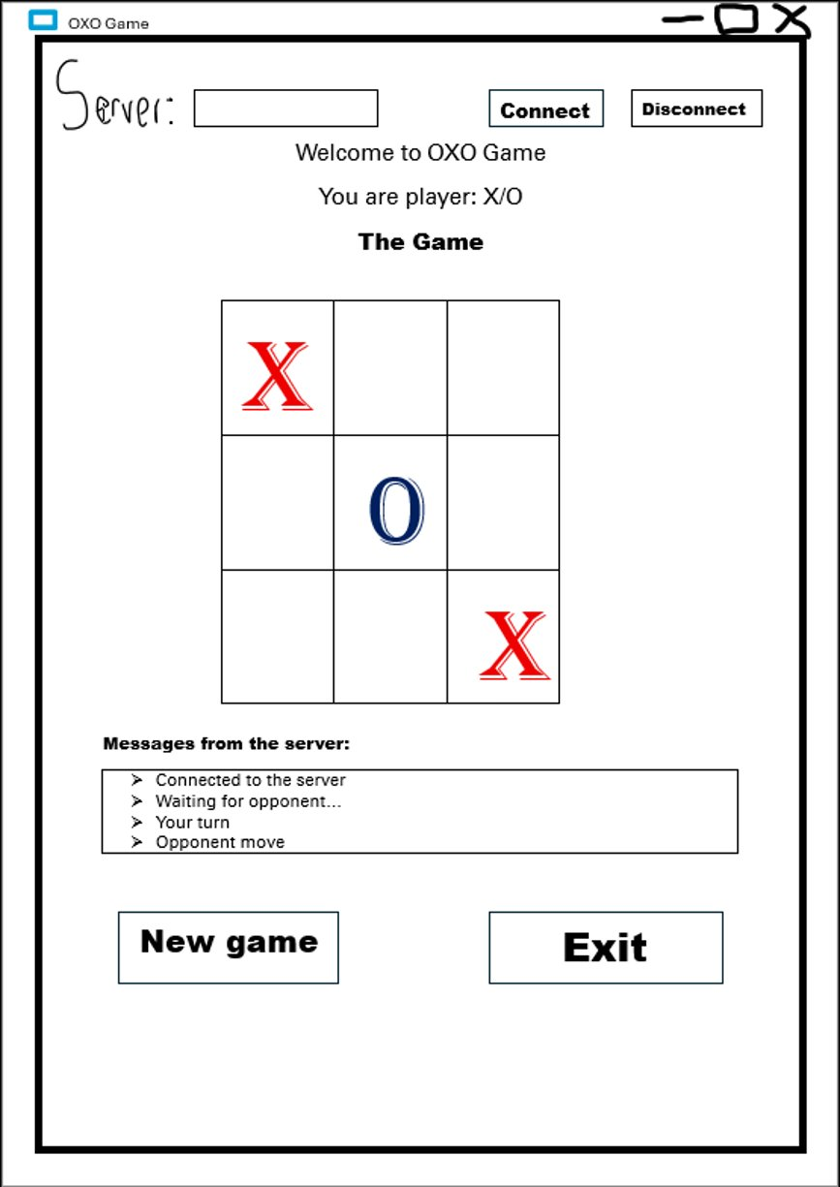
Figure 1: Low-fidelity hand-drawn prototype sketch, main game window layout

3.2 High-Fidelity Prototype
The high-fidelity prototype was the first PyQt5 implementation, produced during Assignment 8. It translated the pencil sketch into working code, allowing the layout and visual proportions to be verified on screen before any server communication was added. At this stage the board rendered blank cells and all buttons were visible but non-functional.

The prototype used a fixed window size of 590 × 800 pixels, with layout managed by QVBoxLayout, QHBoxLayout, and QGridLayout. A light blue-gray default background (#E8EDF5) was chosen to give the interface a calm, professional feel. The seven-colour theme selector (the Nerd Zone feature) was also implemented at this stage.

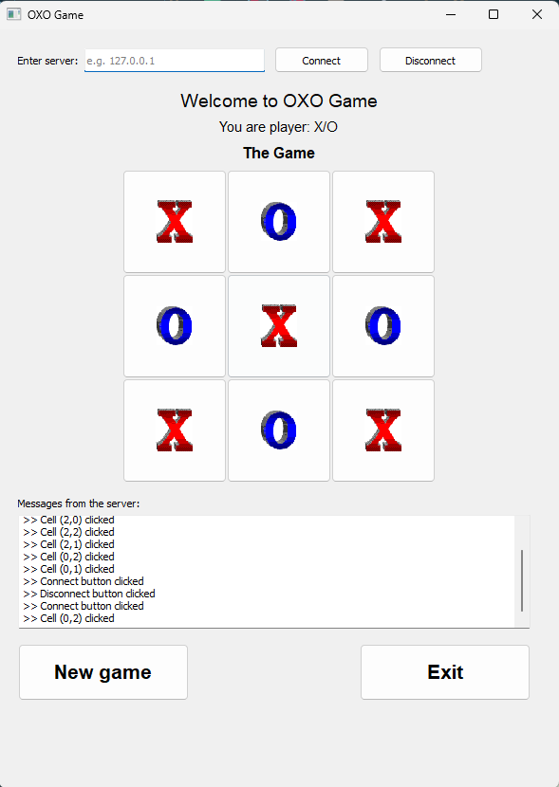
Figure 2: High-fidelity prototype, blank board with colour-selector dropdown visible

3.3 Final User Interface Design
The final user interface incorporated all feedback from user testing. The most consistent criticism of the prototype was that the plain white background was visually unappealing. The response was to default the background to #E8EDF5 (steel blue-gray) and expose the colour selector prominently in the top-right corner.

Additional design decisions applied in the final system:

- The player-identity label (You are player: X/O) was given a rounded pill background (#EEF2F7) to visually separate it from surrounding content.
- X is displayed in red (#E74C3C) and O in blue (#2980B9) in the player label, matching the cross.gif and nought.gif icon colours.
- The Connect button is green (go), Disconnect red (stop), and Help teal — traffic-light colour semantics that communicate button intent without reading labels.
- The message log is given an off-white background (#FAFBFF) to remain readable regardless of the active theme colour.
- Timestamped, colour-coded message log: received messages prefixed with blue "Received:", errors in red, success messages in green.
- Result popups (win, lose, draw) are colour-coded, centred inside the main window, and auto-close after five seconds.

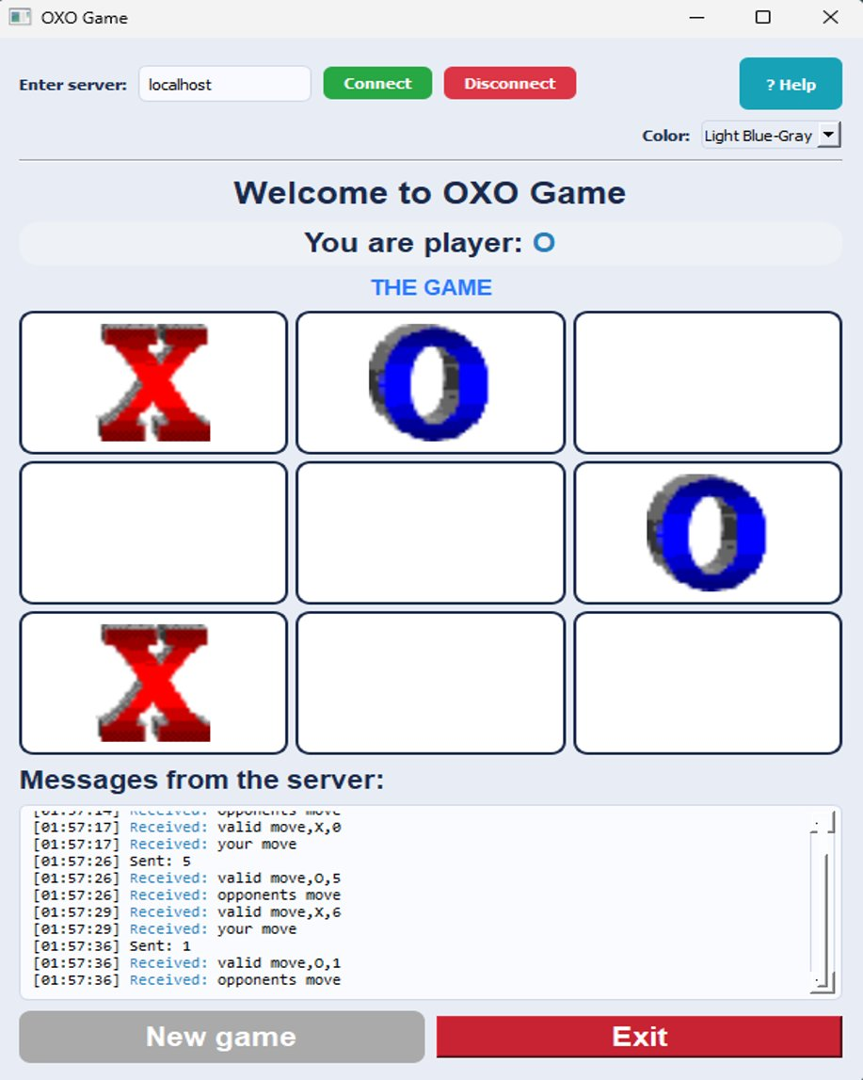
Figure 3: Final user interface, mid-game, default blue-grey theme, both players have placed symbols

Implementation

This section describes the software architecture of the implemented OXO Game Client, the key design decisions, and how each server message type is handled. The complete commented source code is provided in Appendix A.

4.1 Class Architecture
The client is structured around two cooperating classes:

- ResultPopup(QWidget): A frameless, auto-closing overlay widget that displays the game result (YOU WIN! YOU LOSE!, IT'S A DRAW!) in a colour-coded panel centred inside the main window. The LOSE result adds a 150 LOSE!ker animation using QTimer for dramatic effect.
- OXOGUIClient(QWidget): The main application window. It owns the server socket, the background receive thread, the pyqtSignal for thread-safe GUI communication, the 3×3 board of QPushButton cells, the timestamped message log, and all game-state variables.

4.2 Networking and Threading
The client connects to the OXO Game Server using Python's socket library on port 12345 with a 32-byte buffer. The socket is set to a one-second timeout immediately after connecting, preventing recv() from blocking indefinitely. Server messages are received in a background daemon thread (play_loop). Because PyQt5 prohibits direct widget modifications from any thread other than the main thread, the background thread emits a pyqtSignal(str) carrying the raw message string. Qt delivers the signal across the thread boundary and invokes the connected handle_message() slot on the main thread, where all widget updates occur safely.

4.3 Server Message Protocol
Server Message | Client Action | UI Change
"new game, X" or "new game, O" | Store shape; reset board; set turn to False | Board clears; player label shows X (red) or O (blue)
"your move" | my_turn = True; enable empty cells | Board cells become clickable
"opponents move" | my_turn = False; disable all cells | Board disabled; "opponents move" logged
"valid move, S, P" | Place icon at position P for shape S; disable cell | Cell shows cross or nought icon; cell disabled
"invalid move" | Show error; re-enable empty cells | Red error in log; empty cells re-enabled
"game over, W" | Show result popup; enable New game button | Colour-coded popup; board disabled; button enabled
"play again" | No action (server acknowledgement) | No UI change
"exit game" | Set running = False; close socket | "Other player left. Goodbye." shown in log
Table 7: Server message protocol and corresponding client actions

4.4 Connected Window
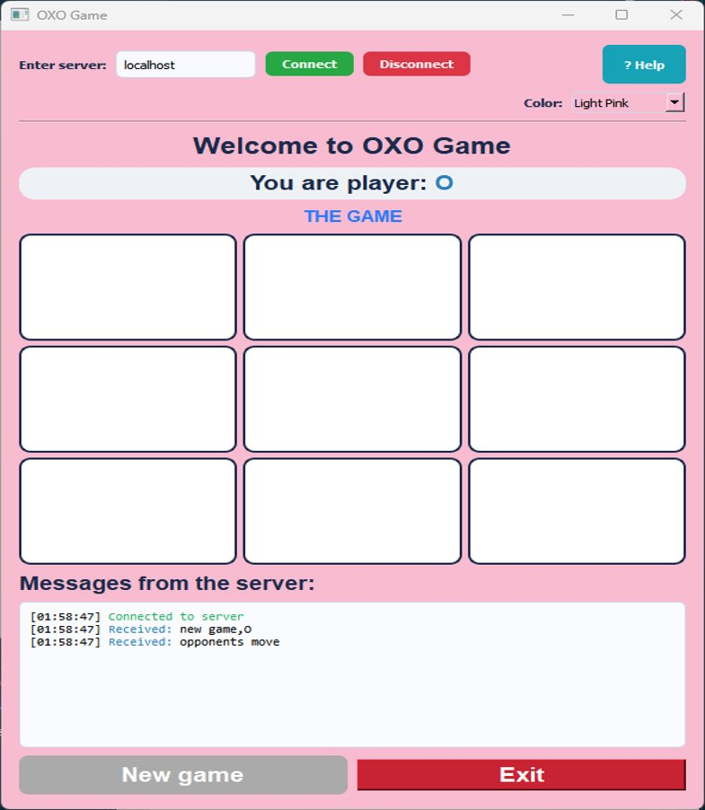
Figure 4: Client connected to server, new game started as player O, Light Pink theme, waiting for opponent

4.5 Game Over Popups
At game over, a ResultPopup appears centred inside the main window and auto-closes after five seconds. The three outcome popups are shown side by side below:

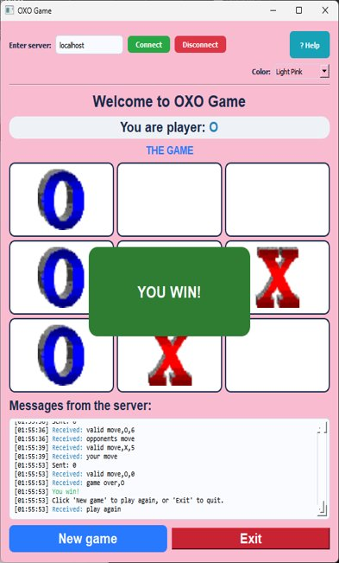  Figure 5: YOU WIN! (green popup) | 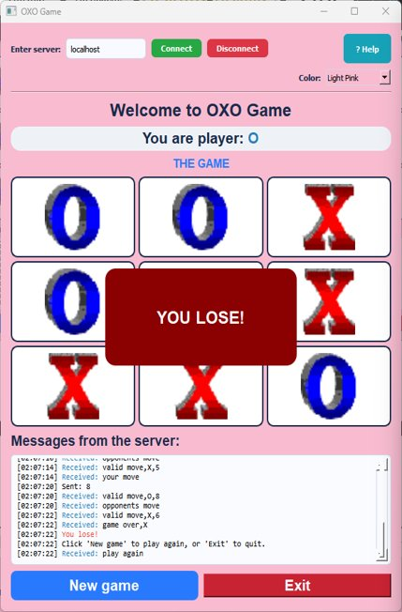  Figure 6: YOU LOSE! (red flickering popup) | 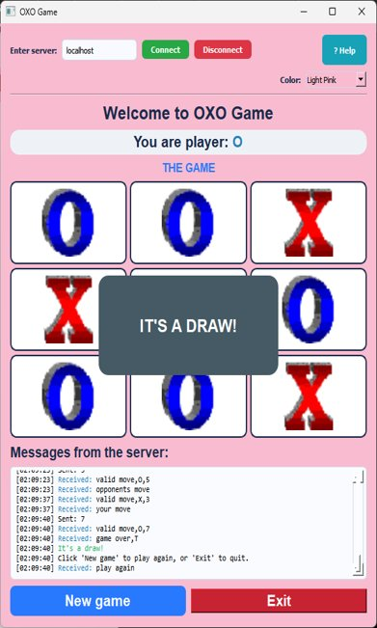  Figure 7: IT'S A DRAW! (dark grey popup)

4.6 Help Screen
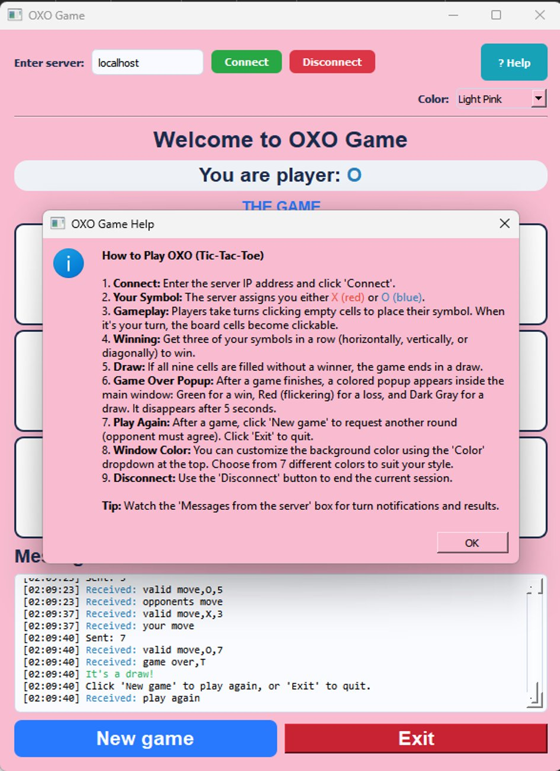
Figure 8: Help screen dialog, nine instructions covering all aspects of the game

4.7 Colour Theme Feature
The seven-colour background theme selector is always visible in the top-right corner of the window. Changing the colour applies instantly without affecting gameplay. The message log maintains its own fixed background (#FAFBFF) regardless of the selected theme, ensuring it always remains legible. Figure 2 above shows the full colour dropdown with all seven options.

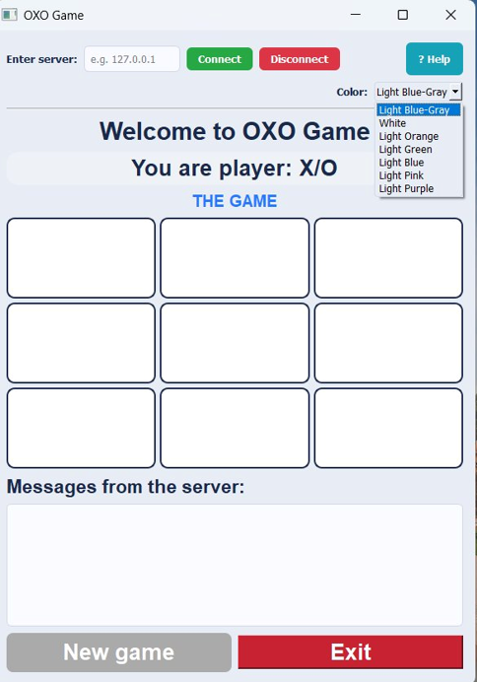
Figure 9: seven-colour background theme selector

Testing
Testing was conducted in two phases: correctness testing to verify that all functional requirements were met, and user testing to evaluate usability with representative end users.

5.1 Correctness Testing
Twenty test scenarios were designed to cover the complete server message protocol, client-side validation, edge cases, and all Nerd Zone features. Every branch of handle_message() is exercised, error conditions are verified, and adverse network conditions are tested.

ID | Test Scenario | Expected Result | Actual Result | P/F
T01 | Connect to server with a valid IP address | Green "Connected to server" message; game thread starts | Connected message shown in green; socket opened; thread launched | Pass
T02 | Connect with an empty or invalid server address | Red error; no socket created | Error shown: "Connection failed: Enter a correct address" | Pass
T03 | Server sends "new game, X" | Board clears; player label shows X in red; cells disabled | Board reset; "You are player: X" shown in red | Pass
T04 | Server sends "new game, O" | Board clears; player label shows O in blue; cells disabled | Board reset; "You are player: O" shown in blue | Pass
T05 | Server sends "your move" | All empty cells become clickable | Empty cells enabled; occupied cells remain disabled | Pass
T06 | Server sends "opponents move" | All cells disabled; event logged | All cells disabled; message logged in blue | Pass
T07 | Player clicks an empty cell on their turn | Move sent as integer position; cells disabled | Position sent; board disabled pending server reply | Pass
T08 | Player clicks an already-occupied cell | Error: "Cell already taken"; no move sent | Red error in log; no server message sent | Pass
T09 | Server sends "valid move, X, 0" | Top-left cell shows cross icon; cell disabled | Cross icon placed at row 0 col 0; cell disabled | Pass
T10 | Server sends "invalid move" | Error shown; empty cells re-enabled for retry | Red error in log; empty cells re-enabled | Pass
T11 | Server sends "game over, X" (player is X) | Green "YOU WIN!" popup; New game button enabled | Green popup shown centred; button enabled | Pass
T12 | Server sends "game over, X" (player is O) | Red flickering "YOU LOSE!" popup; New game enabled | Red flicker popup shown; button enabled | Pass
T13 | Server sends "game over, T" | Dark grey "IT'S A DRAW!" popup; New game enabled | Grey popup shown; button enabled | Pass
T14 | Player clicks New Game after game ends | "y" sent to server; board reset; button disabled | "Requesting new game..." logged; "y" sent | Pass
T15 | Server sends "exit game" | "Other player left" shown; socket closed; thread stops | Message displayed; running = False; socket closed | Pass
T16 | Disconnect button clicked mid-game | Socket closed; running stopped; message shown | Socket closed cleanly; "Disconnected" logged | Pass
T17 | ? Help button clicked | Help QMessageBox opens with nine game instructions | Help dialog displayed with full HTML instructions | Pass
T18 | Colour dropdown changed to Light Pink | Window background changes to #F8BBD0 immediately | Background updated; message log stays readable | Pass
T19 | Window resized with an active result popup | Popup scales proportionally and stays centred | Popup scaled to 30% × 20% of window; repositioned | Pass
T20 | Exit clicked while waiting for play again | "n" sent; 100 ms delay; window closes | 'n' sent; socket closed; window closes cleanly | Pass

All twenty scenarios passed. The most significant bug was an unhandled OSError when the polling loop received on an already-closed socket. This was resolved by explicitly catching OSError alongside ConnectionResetError and ConnectionAbortedError in play_loop().

5.2 User Testing
User testing was conducted during Assignment 9. Five testers were recruited across three categories: two CSC1011H students (who could evaluate technical correctness), two non-CS students (representing the target casual-player audience), and the course tutor (expert evaluation). Each tester interacted with both the text-based client and the GUI prototype, then completed a four-statement questionnaire rated on a five-point Likert scale (Strongly Disagree to Strongly Agree).

The four questionnaire statements were: (1) the text client is user-friendly; (2) the text client works correctly; (3) the GUI layout is well designed; (4) the GUI uses colour well.

Tester | Category | Text Client: User-Friendly | Text Client: Works Correctly | GUI: Layout | GUI: Colour
Langalomso Chulayo | CSC Student | Strongly Agree | Strongly Agree | Strongly Agree | Strongly Agree
Tharollo Kgatla | CSC Student | Strongly Agree | Agree | Strongly Agree | Agree
Zanele | Tutor | Agree | Agree | Agree | Strongly Agree
Sethu Tapa | Non-CS Student | Strongly Agree | Strongly Agree | Strongly Agree | Disagree
Simbongile Mani | Non-CS Student | Strongly Agree | Strongly Agree | Strongly Agree | Average

5.2.1 Text-Based Client Feedback
The text client was well received. All five testers agreed or strongly agreed that it was user-friendly, and four of five strongly agreed that it worked correctly. Key positive comments included:

- Sethu Tapa: "Instructions were straightforward and simple to follow. The program ran smoothly with no complications."
- Simbongile Mani: "It was easy to know when it was my turn, when I had won, and when an invalid move was made."
- Langalomso Chulayo: Strongly agreed the program worked as expected without errors.

Key suggestions for improvement:

- Tharollo Kgatla: Specific error messages should be provided for different error types rather than a generic response.
- Zanele (Tutor): Sufficient comments should be added throughout the code.
- Simbongile Mani: A solo player option against the computer would be beneficial.

5.2.2 GUI Prototype Feedback
The GUI layout received universal approval — all five testers agreed or strongly agreed it was well designed. Colour was the most consistent criticism:

- Langalomso Chulayo: Strongly agreed on everything; commented simply "add colour."
- Tharollo Kgatla: "The only thing missing is a background colour or design."
- Sethu Tapa: Agreed on colour but noted "the interface has no colour, just white — more colours would make the game more attractive."
- Simbongile Mani: "Everything was amazing apart from the colour. The white background is too basic."
- Zanele (Tutor): Strongly agreed overall; the interface was pleasant and well structured.

5.2.3 Changes Made in Response
- A default steel-blue background (#E8EDF5) was added — directly addressing the unanimous feedback about the plain white prototype.
- The message log was given an off-white contrasting background (#FAFBFF) to remain readable regardless of the active theme.
- A seven-colour background theme selector was implemented (Nerd Zone), allowing full personalisation of the interface.
- Specific, colour-coded status messages were added for every server event: connected (green), your move, invalid move (red), and game-over popups (green/red/grey).
- Comprehensive comments and docstrings were added throughout the code, directly in response to the tutor's feedback.

Enhancements & Future Work

6.1 Enhancements Implemented
The following enhancements were implemented beyond the core requirements, constituting the Nerd Zone feature set for this assignment.

6.1.1 Seven-Colour Background Theme Selector
A QComboBox in the top-right corner of the window allows the player to choose from seven background colours: Light Blue Gray (default), White, Light Orange, Light Green, Light Blue, Light Pink, and Light Purple. The background updates instantly on selection without affecting gameplay. The message log maintains its own fixed background regardless of the selected theme. This feature was implemented primarily in response to the unanimous user testing feedback criticising the plain white background.

6.1.2 Interactive Help Screen
A "? Help" button in the top-right corner opens a QMessageBox with nine numbered instructions explaining every aspect of the game. The help text is HTML-formatted with bold headings, colour-coded symbol names (X in red, O in blue), and a tip about the message log. The help screen is accessible at any point and does not interrupt gameplay.

6.1.3 Animated Result Popups
Rather than displaying the game result only in the message log, the client shows a large, centred, colour-coded popup for each outcome:

- Win: solid green (#2E7D32) "YOU WIN!" calm and rewarding.
- Lose: red (#CC0000) with a 150 ms flicker between #CC0000 and #8B0000 "YOU LOSE!" dramatic and attention-grabbing.
- Draw: dark grey (#455A64) “IT'S A DRAW!” neutral and understated.

Each popup is centred inside the main window (not the screen), scales proportionally when the window is resized, closes automatically after five seconds, and only one popup is active at a time

6.1.4 Colour-Coded Timestamped Message Log
Every message log entry is prefixed with a [HH:MM: SS] timestamp and colour-coded by type: received server messages prefixed with blue "Received:"; connection success and win/draw messages in green; errors in red; sent and neutral messages in default colour. The log auto-scrolls to the latest entry. This transforms the log from raw protocol output into a live, readable game record.

6.2 Future Work
The following enhancements are recommended for a future version of the OXO client, should Ten Eleven Games choose to invest in further development.

6.2.1 AI Solo-Player Mode
Multiple user testers suggested that requiring two human players over a network limits accessibility. Implementing a minimax-based AI opponent would allow single-player sessions without needing a server or a second machine. For a 3×3 board, minimax is computationally trivial and would provide optimal-play challenge.

6.2.2 Persistent Score Tracking
Game results are currently displayed momentarily in the popup and then lost. A persistent score tracker, stored locally in a SQLite database, would record each player's win, draw, and loss totals across sessions, adding a competitive dimension to repeated play.

6.2.3 Matchmaking Lobby
Players are currently matched in the order they connect to the server. A lobby system would allow named players to see who is waiting and request specific opponents, making the multiplayer experience more intentional. This would require corresponding server-side changes.

6.2.4 Sound Effects
Short audio cues, a click for placing a symbol, a fanfare for a win, a chord for a draw — would significantly enhance immersion with minimal implementation effort using Python's pygame.mixer or playsound libraries. A mute button could be added to the toolbar.

6.2.5 Responsive Layout and Larger Board Options
The current implementation uses fixed minimum cell sizes. Replacing these with Qt size policies would allow the board to scale with the window. An extended board size (4×4 or 5×5 with a matching win condition) would also increase strategic depth for experienced players.

Conclusion
This report has documented the complete lifecycle of the OXO Game Client from requirements and design through implementation, testing, and enhancement, developed for Ten Eleven Games as the capstone project of CSC1011H at the University of Cape Town.

Development proceeded in five incremental stages. A text-based client confirmed understanding of the server communication protocol. A PyQt5 GUI prototype established the visual layout, confirmed by the low-fidelity sketch produced at the start of Assignment 8. User testing with five participants across three categories revealed a universal preference for a more colourful interface; this feedback was directly addressed in the final system through the seven-colour background theme selector, the colour-coded message log, and the animated result popups.

The final system correctly handles all eight server message types, manages the complete game lifecycle from initial connection through multiple rounds, provides clear visual and textual feedback at every state transition, and includes four Nerd Zone enhancements: animated result popups, a seven-colour theme selector, a comprehensive help screen, and a colour-coded timestamped message log. All twenty correctness test scenarios passed, and all five user testing participants were able to complete their tasks.

Five areas for potential future development have been identified: an AI solo-player mode, persistent score tracking, a matchmaking lobby, sound effects, and a responsive scalable layout. These are recommended for consideration should Ten Eleven Games commission a second version of the product.

This project provided practical, hands-on experience in networked application development, multi-threaded GUI programming, iterative software design, and structured user evaluation, skills directly applicable to professional software engineering careers.

Appendix A - Source Code: OXOGUIClient.py

The listing below contains the complete, well-commented source code for the OXO GUI game client (OXOGUIClient.py). Only student-written code is included; the server-side files provided by the course lecturers (GameIni.py, GameServer.py, OXOGameServer.py, GameClient.py) are excluded as required.

import sys # Import system functions
import socket # Import networking for client-server communication
import threading # Threading so GUI and server run concurrently
from datetime import datetime # Timestamps for message log
from PyQt5.QtWidgets import * # PyQt5 widgets
from PyQt5.QtCore import * # PyQt5 core functions
from PyQt5.QtGui import * # PyQt5 GUI tools: fonts, icons, images

PORT = 12345 # Server port number
BUFFER_SIZE = 32 # Maximum message size (bytes)
BUFFER_STR = '{0:^' + str(BUFFER_SIZE) + '}' # Pads all messages to BUFFER_SIZE

class ResultPopup(QWidget):
# Frameless popup used to display win / lose / draw results.
def __init__(self, parent, message, bg_color, flicker=False):
super().__init__(parent) # Initialise QWidget parent
self.setWindowFlags(Qt.FramelessWindowHint) # No title bar
self.setAttribute(Qt.WA_ShowWithoutActivating) # No focus steal
self.setFixedSize(300, 150)
self.setStyleSheet(f"background-color: {bg_color}; border-radius: 15px;")

layout = QVBoxLayout()
label = QLabel(message)
label.setAlignment(Qt.AlignCenter)
label.setFont(QFont("Arial", 18, QFont.Bold))
label.setStyleSheet("color: white;")
layout.addWidget(label)
self.setLayout(layout)

self.flicker_timer = None
if flicker: # Red flickering effect for LOSE popup
self.flicker_timer = QTimer(self)
self.flicker_timer.timeout.connect(self.toggle_bg)
self.flicker_timer.start(150) # Toggle every 150 ms
self.flip = False

QTimer.singleShot(5000, self.safe_close) # Auto-close after 5 seconds
self.raise_()

def toggle_bg(self):
# Alternates background colour for the flicker animation.
if not self.isVisible():
return
self.flip = not self.flip
colour = "#8B0000" if self.flip else "#CC0000"
self.setStyleSheet(f"background-color: {colour}; border-radius: 15px;")

def safe_close(self):
# Stops the flicker timer and closes the popup safely.
if self.flicker_timer:
self.flicker_timer.stop()
self.close()
self.deleteLater()

class OXOGUIClient(QWidget):
# Main OXO GUI client: handles the window, server connection, and game flow.
message_signal = pyqtSignal(str) # Thread-safe signal from background to main thread

def __init__(self):
QWidget.__init__(self) # Direct parent constructor call – no super()
self.setWindowTitle("OXO Game")
self.setGeometry(200, 100, 590, 800)
self.setStyleSheet("background-color: #E8EDF5;") # Default steel-blue theme

# Game state
self.shape = None # 'X' or 'O' assigned by server
self.socket = None # TCP socket
self.running = False # Whether game loop is active
self.my_turn = False # True when it is this player's turn
self.waiting_for_play_again = False # True after game over
self.active_popup = None # Current result popup

self.message_signal.connect(self.handle_message)

# Colour theme map (Nerd Zone feature)
self.color_map = {
"Light Blue-Gray": "#E8EDF5",
"White": "#FFFFFF",
"Light Orange": "#FFE0B2",
"Light Green": "#C8E6C9",
"Light Blue": "#BBDEFB",
"Light Pink": "#F8BBD0",
"Light Purple": "#D1C4E9",
}

# ── Connection panel ───────────────────────────────────────────────────
self.server_label = QLabel("Enter server:")
self.server_label.setStyleSheet("color: #1B2A4A; font-weight: bold;")
self.input = QLineEdit()
self.input.setPlaceholderText("e.g. 127.0.0.1")
self.input.setStyleSheet(
"border: 1px solid #D0D8E8; border-radius: 6px; padding: 5px; background: #F8FAFF;")
self.connect_button = QPushButton("Connect")
self.connect_button.setStyleSheet(
"QPushButton { background-color: #28A745; color: white; border-radius: 6px;"
" padding: 6px 14px; font-weight: bold; }"
"QPushButton:hover { background-color: #218838; }")
self.connect_button.clicked.connect(self.on_connect)
self.disconnect_button = QPushButton("Disconnect")
self.disconnect_button.setStyleSheet(
"QPushButton { background-color: #DC3545; color: white; border-radius: 6px;"
" padding: 6px 14px; font-weight: bold; }"
"QPushButton:hover { background-color: #C82333; }")
self.disconnect_button.clicked.connect(self.on_disconnect)
self.help_button = QPushButton("? Help")
self.help_button.setFixedSize(70, 40)
self.help_button.setStyleSheet(
"QPushButton { background-color: #17A2B8; color: white; border-radius: 6px; font-weight: bold; }"
"QPushButton:hover { background-color: #138496; }")
self.help_button.clicked.connect(self.show_help)

# ── Colour selector (Nerd Zone) ────────────────────────────────────────
self.color_label = QLabel(" Color:")
self.color_label.setStyleSheet("color: #1B2A4A; font-weight: bold;")
self.color_combo = QComboBox()
self.color_combo.addItems(self.color_map.keys())
self.color_combo.setCurrentIndex(0)
self.color_combo.currentIndexChanged.connect(self.on_color_change)
self.color_combo.setStyleSheet("border: 1px solid #D0D8E8; border-radius: 4px; padding: 2px;")

# ── Game info labels ───────────────────────────────────────────────────
self.welcome_label = QLabel("Welcome to OXO Game")
self.welcome_label.setAlignment(Qt.AlignCenter)
self.welcome_label.setFont(QFont("Arial", 18, QFont.Bold))
self.welcome_label.setStyleSheet("color: #1B2A4A;")
self.name_of_player = QLabel("You are player: X/O")
self.name_of_player.setAlignment(Qt.AlignCenter)
self.name_of_player.setFont(QFont("Arial", 16, QFont.Bold))
self.name_of_player.setStyleSheet(
"color: #1B2A4A; background-color: #EEF2F7; border-radius: 14px; padding: 4px 20px;")
self.game_title = QLabel("THE GAME")
self.game_title.setAlignment(Qt.AlignCenter)
self.game_title.setFont(QFont("Arial", 12, QFont.Bold))
self.game_title.setStyleSheet("color: #2979FF;")

# ── 3x3 board ──────────────────────────────────────────────────────────
self.cells = []
for r in range(3):
row = []
for c in range(3):
btn = QPushButton("")
btn.setIconSize(QSize(90, 90))
btn.clicked.connect(self.make_handler(r, c))
btn.setStyleSheet(
"QPushButton { border: 2px solid #1B2A4A; background-color: white; border-radius: 10px; }"
"QPushButton:hover { background-color: #F0F4FF; }"
"QPushButton:disabled { border: 2px solid #1B2A4A; background-color: white; border-radius: 10px; }")
row.append(btn)
self.cells.append(row)

# ── Message log ────────────────────────────────────────────────────────
self.messages_label = QLabel("Messages from the server:")
self.messages_label.setFont(QFont("Arial", 14, QFont.Bold))
self.messages_label.setStyleSheet("color: #1B2A4A;")
self.messages_box = QTextEdit()
self.messages_box.setReadOnly(True)
self.messages_box.setStyleSheet(
"background-color: #FAFBFF; border: 1px solid #D0D8E8;"
" border-radius: 6px; padding: 4px; font-family: Consolas; font-size: 11px;")

# ── Action buttons ─────────────────────────────────────────────────────
self.new_game_btn = QPushButton("New game")
self.new_game_btn.setFont(QFont("Arial", 16, QFont.Bold))
self.new_game_btn.setStyleSheet(
"QPushButton { background-color: #2979FF; color: white; border-radius: 8px; padding: 8px; }"
"QPushButton:hover { background-color: #1565C0; }"
"QPushButton:disabled { background-color: #AAAAAA; }")
self.new_game_btn.clicked.connect(self.on_new_game)
self.new_game_btn.setEnabled(False)
self.exit_btn = QPushButton("Exit")
self.exit_btn.setFont(QFont("Arial", 16, QFont.Bold))
self.exit_btn.clicked.connect(self.on_exit)
self.exit_btn.setStyleSheet("background-color: #C82333; color: white;")

# ── Layout assembly ────────────────────────────────────────────────────
main_layout = QVBoxLayout()
main_layout.setSpacing(8)
main_layout.setContentsMargins(15, 15, 15, 15)
self.setLayout(main_layout)

hbox1 = QHBoxLayout()
for w in [self.server_label, self.input, self.connect_button,
self.disconnect_button]:
hbox1.addWidget(w)
hbox1.addStretch()
hbox1.addWidget(self.help_button)
main_layout.addLayout(hbox1)

hbox2 = QHBoxLayout()
hbox2.addStretch()
hbox2.addWidget(self.color_label)
hbox2.addWidget(self.color_combo)
main_layout.addLayout(hbox2)

sep = QFrame()
sep.setFrameShape(QFrame.HLine)
sep.setFrameShadow(QFrame.Sunken)
main_layout.addWidget(sep)
main_layout.addWidget(self.welcome_label)
main_layout.addWidget(self.name_of_player)
main_layout.addWidget(self.game_title)

grid = QGridLayout()
grid.setSpacing(5)
grid.setAlignment(Qt.AlignCenter)
for r in range(3):
for c in range(3):
self.cells[r][c].setSizePolicy(QSizePolicy.Expanding, QSizePolicy.Expanding)
self.cells[r][c].setMinimumSize(80, 80)
grid.addWidget(self.cells[r][c], r, c)
main_layout.addLayout(grid)

main_layout.addWidget(self.messages_label)
self.messages_box.setMaximumHeight(150)
main_layout.addWidget(self.messages_box)

hbox3 = QHBoxLayout()
hbox3.addWidget(self.new_game_btn, 1)
hbox3.addWidget(self.exit_btn, 1)
main_layout.addLayout(hbox3)

# Load cell icons
self.blank_icon = self.create_icon("blank.gif")
self.cross_icon = self.create_icon("cross.gif")
self.nought_icon = self.create_icon("nought.gif")
self.clear_board()

# ── Colour theme ──────────────────────────────────────────────────────────
def on_color_change(self, index):
name = self.color_combo.currentText()
hex_color = self.color_map.get(name, "#E8EDF5")
self.setStyleSheet(f"background-color: {hex_color};")
if self.active_popup and self.active_popup.isVisible():
self.center_popup(self.active_popup)

# ── Icon helper ───────────────────────────────────────────────────────────
def create_icon(self, path):
pixmap = QPixmap(path)
pixmap = pixmap.scaled(90, 90, Qt.KeepAspectRatio, Qt.SmoothTransformation)
icon = QIcon()
icon.addPixmap(pixmap, QIcon.Normal)
icon.addPixmap(pixmap, QIcon.Disabled)
return icon

def make_handler(self, r, c):
return lambda: self.on_cell_clicked(r, c)

# ── Logging ───────────────────────────────────────────────────────────────
def append_coloured_message(self, text, colour=None, prefix=None, prefix_colour=None):
# Appends a timestamped, HTML-formatted entry to the message log.
timestamp = datetime.now().strftime("[%H:%M:%S]")
if prefix and prefix_colour:
html = f'{timestamp} <span style="color:{prefix_colour};">{prefix}</span> {text}'
elif colour:
html = f'{timestamp} <span style="color:{colour};">{text}</span>'
else:
html = f'{timestamp} {text}'
self.messages_box.append(html)
self.messages_box.setHtml(self.messages_box.toHtml())
self.messages_box.verticalScrollBar().setValue(
self.messages_box.verticalScrollBar().maximum())

# ── Help screen (Nerd Zone) ───────────────────────────────────────────────
def show_help(self):
help_text = (
"<b>How to Play OXO (Tic-Tac-Toe)</b><br><br>"
"1. <b>Connect:</b> Enter the server IP and click Connect.<br>"
"2. <b>Your Symbol:</b> The server assigns you X (red) or O (blue).<br>"
"3. <b>Gameplay:</b> Take turns clicking empty cells to place your symbol.<br>"
"4. <b>Winning:</b> Get three symbols in a row (horizontal, vertical or diagonal).<br>"
"5. <b>Draw:</b> All nine cells filled with no winner.<br>"
"6. <b>Game Over Popup:</b> Green=Win, Red flicker=Lose, Grey=Draw.<br>"
"7. <b>Play Again:</b> Click New Game to request another round.<br>"
"8. <b>Window Color:</b> Use the Color dropdown to change the background.<br>"
"9. <b>Disconnect:</b> Click Disconnect to end the current session.")
QMessageBox.information(self, "OXO Game Help", help_text)

# ── Popup management ──────────────────────────────────────────────────────
def center_popup(self, popup):
if popup is None: return
pr, ps = self.rect(), popup.size()
popup.move(pr.x() + (pr.width() - ps.width()) // 2,
pr.y() + (pr.height() - ps.height()) // 2)

def close_existing_popup(self):
if self.active_popup is not None:
try: self.active_popup.safe_close()
except: pass
self.active_popup = None

def _show_popup(self, msg, color, flicker=False):
self.close_existing_popup()
self.active_popup = ResultPopup(self, msg, color, flicker)
self.active_popup.destroyed.connect(lambda: setattr(self, 'active_popup', None))
self.active_popup.show()
self.center_popup(self.active_popup)

def show_win_popup(self): self._show_popup("YOU WIN!", "#2E7D32", False)
def show_lose_popup(self): self._show_popup("YOU LOSE!", "#CC0000", True)
def show_draw_popup(self): self._show_popup("IT'S A DRAW!", "#455A64", False)

def resizeEvent(self, event):
super().resizeEvent(event)
if self.active_popup and self.active_popup.isVisible():
self.active_popup.setFixedSize(int(self.width() * 0.3), int(self.height() * 0.2))
self.center_popup(self.active_popup)

def moveEvent(self, event):
super().moveEvent(event)
if self.active_popup and self.active_popup.isVisible():
self.center_popup(self.active_popup)

# ── Networking ────────────────────────────────────────────────────────────
def on_connect(self):
addr = self.input.text().strip()
if not addr:
self.append_coloured_message("Enter server address", "#E74C3C")
return
try:
self.socket = socket.socket(socket.AF_INET, socket.SOCK_STREAM)
self.socket.connect((addr, PORT))
self.socket.settimeout(1.0) # Non-blocking with 1-second timeout
self.append_coloured_message("Connected to server", "#27AE60")
self.running = True
threading.Thread(target=self.play_loop, daemon=True).start()
except Exception:
self.append_coloured_message("Connection failed: Enter a correct address", "#E74C3C")

def on_disconnect(self):
self.running = False
if self.socket:
try: self.socket.close()
except: pass
self.append_coloured_message("Disconnected", None)

def send(self, msg):
self.append_coloured_message(f"Sent: {msg}", None)
if self.socket:
try: self.socket.sendall(BUFFER_STR.format(msg).encode())
except: pass

def play_loop(self):
# Background thread: receives server messages and emits them as signals.
while self.running:
try:
data = self.socket.recv(BUFFER_SIZE)
if not data:
self.message_signal.emit("exit game"); break
msg = data.decode(errors="ignore").strip()
if msg:
self.message_signal.emit(msg)
except socket.timeout:
continue # No data yet; keep waiting
except (ConnectionResetError, ConnectionAbortedError, OSError):
self.message_signal.emit("exit game"); break
except Exception:
self.message_signal.emit("exit game"); break

# ── Message handler (runs on main thread via signal) ──────────────────────
def handle_message(self, msg):
self.append_coloured_message(msg, prefix="Received:", prefix_colour="#2980B9")
parts = msg.split(",")

if parts[0] == "new game":
self.shape = parts[1]
sym = self.shape
coloured = ('<span style="color:#E74C3C;font-weight:bold;">X</span>' if sym == 'X'
else '<span style="color:#2980B9;font-weight:bold;">O</span>')
self.name_of_player.setText(f"You are player: {coloured}")
self.name_of_player.setTextFormat(Qt.RichText)
self.clear_board()
self.my_turn = False
self.waiting_for_play_again = False
self.new_game_btn.setEnabled(False)

elif msg == "your move":
self.my_turn = True; self.enable_board(True)

elif msg == "opponents move":
self.my_turn = False; self.enable_board(False)

elif parts[0] == "valid move":
shape, pos = parts[1], int(parts[2])
r, c = pos // 3, pos % 3
self.cells[r][c].setIcon(self.cross_icon if shape == "X" else self.nought_icon)
self.cells[r][c].setEnabled(False)

elif msg == "invalid move":
self.append_coloured_message("Invalid move. Please try again", "#E74C3C")
self.enable_board(True)

elif parts[0] == "game over":
winner = parts[1]
self.my_turn = False; self.enable_board(False)
if winner == "T":
self.append_coloured_message("It's a draw!", "#27AE60"); self.show_draw_popup()
elif winner == self.shape:
self.append_coloured_message("You win!", "#27AE60"); self.show_win_popup()
else:
self.append_coloured_message("You lose!", "#E74C3C"); self.show_lose_popup()
self.waiting_for_play_again = True
self.new_game_btn.setEnabled(True)
self.append_coloured_message("Click 'New game' to play again, or 'Exit' to quit.", None)

elif msg == "play again":
pass # Server acknowledgement; no action needed

elif msg == "exit game":
self.append_coloured_message("Other player left. Goodbye.", None)
self.running = False
self.new_game_btn.setEnabled(False)
if self.socket:
try: self.socket.close()
except: pass

else:
self.append_coloured_message(f"Unknown message: {msg}", "#E74C3C")

# ── Cell interaction ──────────────────────────────────────────────────────
def on_cell_clicked(self, r, c):
if not self.my_turn:
self.append_coloured_message("Not your turn", "#E74C3C"); return
if self.cells[r][c].icon().cacheKey() != self.blank_icon.cacheKey():
self.append_coloured_message("Cell already taken", "#E74C3C"); return
pos = r * 3 + c # Convert (row, col) to 0-8 position index
self.send(str(pos))
self.my_turn = False; self.enable_board(False)

# ── Game flow ─────────────────────────────────────────────────────────────
def on_new_game(self):
if self.waiting_for_play_again:
self.send('y')
self.waiting_for_play_again = False
self.new_game_btn.setEnabled(False)
self.append_coloured_message("Requesting new game...", None)
else:
self.append_coloured_message("No game finished yet, keep playing", "#E74C3C")

def on_exit(self):
if self.waiting_for_play_again:
self.send('n'); QTimer.singleShot(100, self._close)
else:
self._close()

def _close(self):
if self.socket:
try: self.socket.close()
except: pass
self.close()

# ── Board helpers ─────────────────────────────────────────────────────────
def clear_board(self):
for row in self.cells:
for btn in row:
btn.setIcon(self.blank_icon); btn.setEnabled(False)

def enable_board(self, enabled):
for row in self.cells:
for btn in row:
if enabled and btn.icon().cacheKey() == self.blank_icon.cacheKey():
btn.setEnabled(True)
else:
btn.setEnabled(False)

def main():
app = QApplication(sys.argv)
win = OXOGUIClient()
win.show()
sys.exit(app.exec_())

if __name__ == "__main__":
main()

